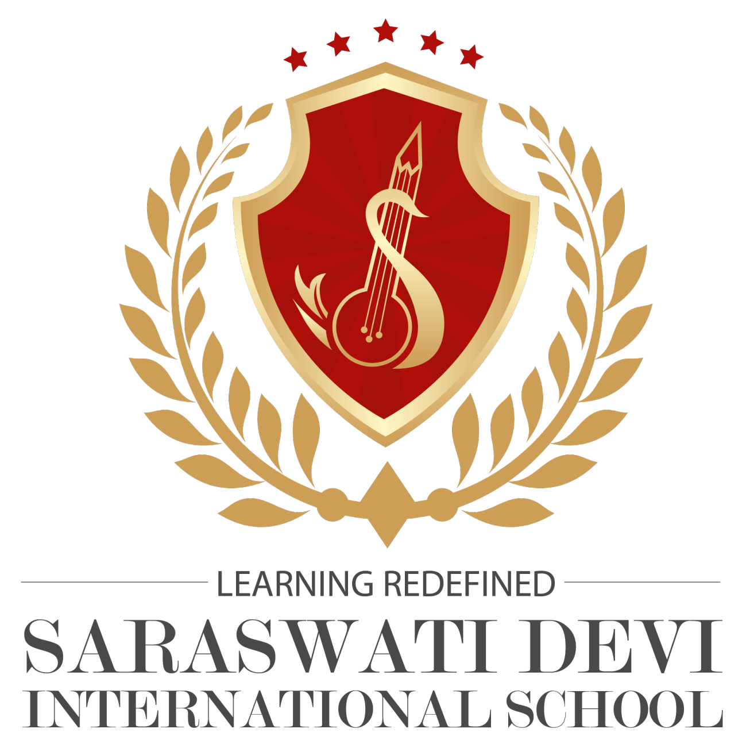
SARASWATI DEVI INTERNATIONAL SCHOOL
Puabagan :: Damodarpur :: Bankura :: PIN-722146 (W.B.)
CLASS -SEC: 1 A |  | SUB: ENGLISH | DATE:1/05/2021 |  | Teacher's Name:  KHUSHBOO KUMARI
SL.NO. | NAME |  |  | M.O. |  | FM.
1. | Aatri Pal |  |  | 20 |  | 20
2. | Ankur Mahanty |  |  | 20 |  | 20
3. | Anshika Banerjee |  |  | 20 |  | 20
4. | Archit Pramanik |  |  | 20 |  | 20
5. | Aritra Maji |  |  | 19 |  | 20
6. | Ariyan Midya |  |  | 20 |  | 20
7. | Arpan S.M Patra |  |  | 20 |  | 20
8. | Arunava chatterjee |  |  | 20 |  | 20
9. | Bartika Saren |  |  | 20 |  | 20
10. | Chirag Patel |  |  | 16 |  | 20
11. | Debdutta Sen |  |  | 20 |  | 20
12. | Manish Bhakat |  |  | 20 |  | 20
13 | Mrittika Hansda |  |  | 19 |  | 20
14. | Mehtaj Middya |  |  | 0 |  | 20
15. | Nilesh Sarkar |  |  | 19 |  | 20
16. | Nishant Reddy Shetty |  |  | 20 |  | 20
17. | Oindrila Biswas |  |  | 19 |  | 20
18. | Pareshnath gorai |  |  | 18 |  | 20
19 | Rajdeep bhakat |  |  | 20 |  | 20
20 | Ankush pati |  |  | 20 |  | 20
21 | Samriddhi dhuan |  |  | 20 |  | 20
22 | Samriddhi mukherjee |  |  | 20 |  | 20
23 | Sayantika Mandal |  |  | 19 |  | 20
24 | Soham Banerjee |  |  | 20 |  | 20
25 | Soham pain |  |  | 20 |  | 20
26 | Soumya Chattopadhyay |  |  | 20 |  | 20
27 | Srija Halder |  |  | 20 |  | 20
28 | Sukanya biswas |  |  | 20 |  | 20
29 | Swapnil pal |  |  | 20 |  | 20
30. | Tanishka chakraborty |  |  | 20 |  | 20
31 | Win sing |  |  | 20 |  | 20
32 | Shivraj goswami |  |  | 20 |  | 20
33 | Arnab mandal |  |  | 20 |  | 20
34 | Erina Barman |  |  | 19 |  | 20
35 | Sneha Mondal |  |  | 20 |  | 20
 |  |  |  |  |  | 20
 |  |  |  |  |  | 20
 |  |  |  |  |  | 20
 |  |  |  |  |  | 20
 |  |  |  |  |  | 20
 |  |  |  |  |  | 20
 |  |  |  |  |  | 20
 |  |  |  |  |  | 20

